**DOMESTIC ABUSE – C-19 SUPERMARKET RECEIPT MESSAGING**

**WHERE TO GET HELP**

**Are you feeling threatened or unsafe in your home?** Social restrictions may have a serious impact on those experiencing domestic abuse.

**Call 999 if you or someone else is in danger. If it is not an emergency, please call 101.**

**Refuge – Freephone 24 hour National Domestic Abuse Helpline**

**0808 2000 247**

**Men’s Advice Line is a confidential helpline for male victims of domestic abuse and those supporting them.**

**0808 8010327**

**(***Text relay services available)*

**Scan code for further support at**

[**www.gov.uk/domestic-abuse**](http://www.gov.uk/domestic-abuse)

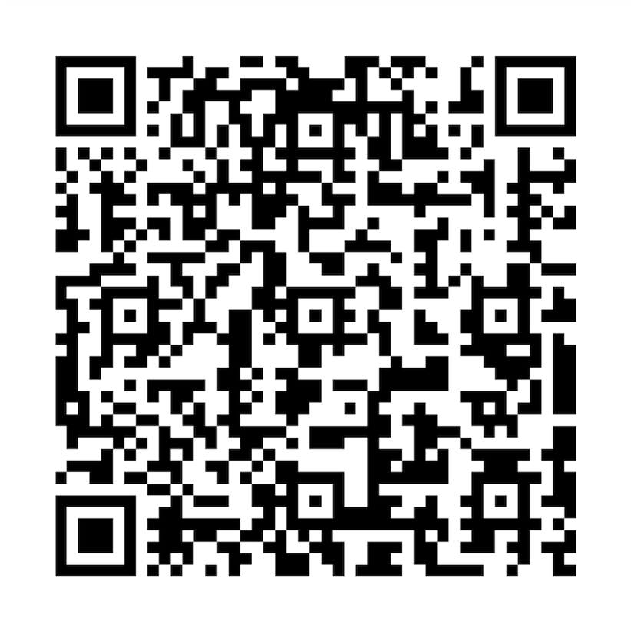*#YouAreNotAlone*

Advice and support is available for everyone regardless of background, financial situation, disability and nationality or immigration status.