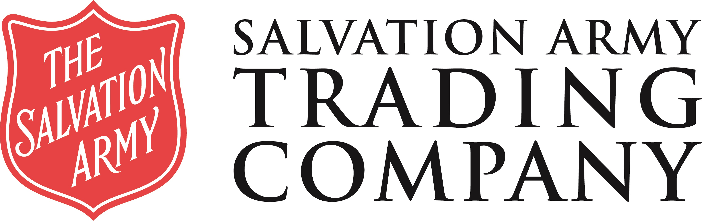

24 March 2020

ANNOUNCEMENT OF TEMPORARY CLOSURE OF CLOTHING BANKS

Following the Prime Minister’s announcement yesterday, it is with great regret we have to temporarily close our clothing collection operation from close of business today.

Textiles are not deemed ‘waste’ and our collectors have not been granted key worker status, therefore in order to limit the risk to all of our colleagues and donors, SATCoL has no choice but to close down this operation. This means that no collections will be done from any textile banks after today and until further notice.
The current crisis is a fast moving and changing environment – decisions that are appropriate one day, are not in compliance with Government rules the next. Staff welfare remains our highest priority and the decision to close is clearly now the only policy which enables colleagues and contractors alike to follow, to the letter, guidelines given by the Government and Public Health England for staying at home, social distancing and staying safe. We will continue to monitor the Government advice and instructions and will back up and running as soon as practically possible.
With your agreement, self-adhesive clothing bank closure notices will be sent to your locations; in order to mitigate the risk of full banks and potential fly tipping I would ask if you could please request your store managers to place these in a prominent position on the textile banks. The notices outline that we are no longer taking donations due to the COVID 19 outbreak.

A member of our team will be in contact with you soon and we will be posting updates on our website. In the meantime, if you have any questions regarding this notice, please contact XXXX.
I am sure that you will fully support our decision that will assist in trying to contain this pandemic and you understand we do not take this action lightly. We will return to a normal high level of service to support you to the fullest when Government restrictions are lifted.

Yours sincerely
Kirk Bradley

Kirk Bradley
Head of Corporate Partnerships

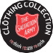
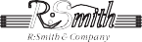
Salvation Army Trading Company Limited, 66-78 Denington Road, Denington Industrial Estate, Wellingborough, Northants NN8 2QH Telephone +44 (0)1933 441807 Fax +44 (0)1933 443006

Registered Company no. 2605817 The Salvation Army registered charity no. 214779 and in Scotland no. SC009359

