NEXT STEPS

Meeting date: 5th November 2020

Group Meeting: Buying Community Meeting
Emerging Risk and Product Issues Meeting

Location: Teams

Item | SUBJECT
1. | Introduction  Members were welcomed, the competition statement shared, and members were reminded that the meeting was being held under Chatham House Rule.
2. | COMMON ISSUES & EMERGING RISKS
2.1 | Cosmetics: CTPA Advice updated  https://brc.org.uk/news/buying/brexit-cosmetics/  https://www.ctpa.org.uk/news/important-new-ctpa-brexit-factsheets-4877  The CTPA are going to run 2 Brexit webinars until the end of the year. 16th November and 3rd December for members and non- members. BRC members invited. All information and registration links are available here. | All | 16th Nov  3rd Dec
2.2 | Cosmetics  No regulations published yet, unlikely to differ from no-deal scenario for GB  Question of need for the RP to be in bold and underlined could be confusing for NI and GB compliance.  Do PIF files need to be in 2 locations?  Do they need to be stored at a UK address / EU address or both?  Carry over. BEIS to organise workshop | DB | TBC
2.3 | Michael Kearney (BEIS/OPSS)  Michael is the Business Liaison Representative, and members way into BEIS. He is the central point of contact  Members requested contact details  Michael Kearney  Michael.Kearney@beis.gov.uk  Head of Business Engagement  07881359680 | DB
2.4 | Placed on the Market  - The concept of placing on the market refers to each individual product, not to a type of product, whether it was manufactured as an individual unit or in a series.  - A product is placed on the market (in the UK or EU) when it is made available for the first time on the market, i.e. when it is first supplied for distribution, consumption or use on the market in the course of a commercial activity, whether in return for payment or free of charge. This can be either when a new manufactured product, or a product imported from a third country (new or used), is made available on the market for the first time.  - Placing a product on the market supposes that there is an offer or an agreement for the transfer of ownership, possession, or any other kind of right (excluding intellectual property rights) concerning the product in question after the manufacturing stage has taken place. It does not require physical delivery of the product.  Members requested a copy of the BEIS communication for their personal records:  “my understanding of it is that it requires clear evidence (personally I don’t think verbal would cut it) of an order being placed for the products before the cut off date, even though products might not yet have been dispatched (or even manufactured as you say).”  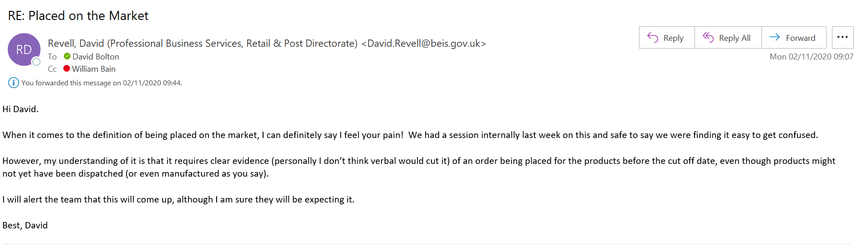  Also note subsequently also from David Revell at BEIS:  Here is the guidance that was published last time round and still stands so I understand.  https://assets.publishing.service.gov.uk/government/uploads/system/uploads/attachment_data/file/792539/placing-on-market-definition.pdf
2.5 | Notified Bodies  https://www.gov.uk/guidance/conformity-assessment-bodies-change-of-status-from-1-january-2021  Will become Assessment Bodies  - UK will not recognise GB and GB will not recognise EU  - Only exception is pyrotechnics where there is no UK presence.  - EU Notified Bodies:  https://ec.europa.eu/growth/tools-databases/nando/index.cfm?fuseaction=directive.pdf&refe_cd=93%2F42%2FEEC&requesttimeout=900
2.6 | Pharmaceuticals  Gov has produced guidelines  BEIS has been running workshops with BRC Members  If you’d like to join please let William Bain know. Pleas note this is not a BRC meeting.  Next meeting Nov 23rd @ 11.00
2.7 | Resignation  David Bolton announced that he would be retiring on Jan 1st 2021  Anyone interested in his post can contact either David or Andrew Opie andrew.opie@brc.org.uk or the  Application is available on-line; https://brc.org.uk/about/vacancies/
2.8 | Members Bulletin  Feedback requested from members on new format: | All | ongoing
Future Meetings 10.00 - 11.30

Meeting, schedule has been sent via outlook
Please send Agenda items in advance.
All meetings 10.00-11.30
November 19th
December 3rd 17th

Members agreed to continue fortnightly meetings due to level of activity. Renew for the new year.

19th Nov
Phil LeShirley RoSPA: Priorities + Primary Authority Relationship + Magnets issue

Dec 3rd
Emma Drackford Electrical Safety First
ESF have created an App which is being rolled out on Alexa and Google Home smart Technology. It allows a user to quote the make and model of a products and Google/Alexa will be able to confirm if it has been the subject of a previous product safety recall.

ESF are currently putting together some social media videos/infographics to help promote the apps and they would be looking for retailers to share on our social channels and website.

The advantage of these Apps would be that customers ‘opt in’ therefore no conflict with RTGF and GDPR.
Also, for large capital purchases such as ovens, washing machines, light fittings etc. which stay in the home when the owner or landlord is no longer there, it allows a new owner/tenant visibility of any items in the home which have been the subject to a previous product safety recall.

