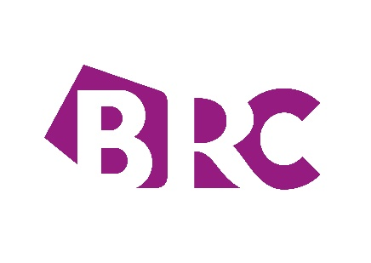

YOUR SUBMISSION FOR THE RETAILER 2021 SUMMER EDITION

Please complete and return the completed form to theretailer@brc.org.uk by close of play Monday 14 June 2021.

(Please note we will be unable to accept synopsis submitted after this deadline)

A member of the team will be in touch following your submission to confirm receipt of the synopsis and to discuss the next steps.

For further information and guidance for submissions to The Retailer, check out our How to Guide.

- You are choosing to submit to the Summer edition of The Retailer

- Publication date w/c 9 August 2021.
- Latest you can submit your synopsis Monday 14 June 2021.
- Deadline for submission of your final Article Monday July 2021.

- Your contact information

Name:

Organisation:

Job title:

Email address:

- Your synopsis

Please provide a brief outline of what your article will cover. Max 200 words.

Thank you for your submission. We look forward to working with you on the next edition.

